

press release
(English translation)

MIR 2025: TARGETS REACHED, + 30% ATTENDANCE ON 2024

- A large turnout and a winning overall strategy for the Italian Exhibition Group event
- Foreign attendance on the rise: a 25% increase in international exhibitors
- Save the date for 2026, from March 29 to 31.

Rimini (Italy), 25 March 2025 - Today wrapped things up for MIR 2025 - The Future of Audiovisual and Entertainment Technology. The spotlight, however, shines on the record-breaking results achieved by this edition (+30% attendance on 2024), marking a new chapter in the event's growth. This event in Rimini (Italy) has become the beating heart of innovation for the audiovisual and entertainment industry, confirming it as a reference point for companies and professionals. The strategy, initiated three years ago, has yielded significant results. The event saw a significant increase in exhibitors, with over 200 brands represented. 15% of the participants were foreign companies, and 19% of the total were international attendees, with Germany, Great Britain, China, and the Netherlands leading the way, a clear indication of MIR's growing global reach.

With 8 halls and over 40,000 square metres of exhibit space, MIR has established itself as a strategic hub for networking, innovation, and business opportunities. The edition has responded to the needs of an evolving market with even more precision, creating an ideal space for companies, buyers, and decision-makers to come together. The Live You Play “pillar feature” has solidified its key role within the event, offering professionals a direct experience of the most advanced audio and entertainment solutions. This includes 26 hours of programming, featuring live and virtual shows, four interactive stages, and the spectacular Immersive Rooms for multidimensional audio experiences. Among the highlights of this year's event was Sound Power, an outdoor area dedicated to showcasing the most innovative audio systems live.

THE INNOVATIONS THAT MADE THE 2025 EDITION TRULY UNIQUE
The event kicked off with a keynote from Luigi De Siervo, CEO of Lega Serie A, who took a deep dive into the latest strategies for producing and distributing sports content during the inaugural panel, “The Evolutionary Path of Sports Content”. This moment underscored the crucial role of technology in revolutionising the audiovisual sector and broadcast production. The Corporate Communication Pavilion was also a hit, where companies and professionals had the chance to explore the latest innovations in corporate communication, from interactive LED walls to advanced video conferencing platforms. In partnership with SIEC, over 15 workshops and networking opportunities were provided, all focused on business solutions. The world of electronic music and clubbing has once again found its home in MIR, with MIR CLUB, which has been offering a perfect blend of training and innovation for the third year in a row. In addition to the largest console exhibition ever seen in Italy, the programme boasted the presence of industry leaders such as Albertino, Big Fish, Andro, Roberto Intrallazzi, Albert Marzinotto, Giacomo Maiolini, Sergio Cerruti, Dj Skizo, Dj Aladyn, and Master Freez.

MIR LOOKING TO THE FUTURE: SEE YOU IN 2026
The energy, growth, and international scope of this edition underscore MIR's status as a pivotal reference point for the entire industry. With an unprecedented turnout and participation, the success of MIR 2025 is just the beginning of an expanding journey. The team is already hard at work for MIR 2026, set to take place from March 29 to 31, with the goal of delivering an even more innovative and engaging experience. New technologies, formats, and opportunities for business and training are already taking shape, promising to make the next edition even more unforgettable.

ABOUT MIR 2025
Date: 23/25 March 2025; event type: international expo; organiser: Italian Exhibition Group S.p.A.; recurrence: annual; edition: 9th; open to: professional operators and general public; info: www.mirtechexpo.com

PRESS CONTACT ITALIAN EXHIBITION GROUP
head of corporate communication & media relation: Elisabetta Vitali
press office manager: Marco Forcellini, Pier Francesco Bellini | press office coordinator: Luca Paganin | international press office coordinator: Silvia Giorgi | press office specialist: Mirko Malgieri; Nicoletta Evangelisti | media@iegexpo.it

MEDIA AGENCY MIR
Naper Multimedia| Zoe Perna | T. +39 02 97699600 | zoe.perna@napermultimedia.it | staff@napermultimedia.it

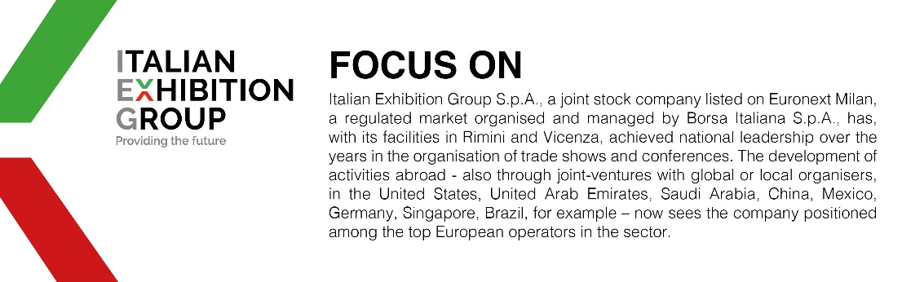

This press release contains forecast elements and estimates that reflect the management´s current opinions (´forward-looking statements´), particularly regarding future management performance, realization of investments, cash flow trends and the evolution of the financial structure. For their very nature, forward-looking statements have a component of risk and uncertainty, as they depend on the occurrence of future events. The effective results may differ (even significantly) from those announced, due to numerous factors, including, only by way of example: food service market and tourist flow trends in Italy, gold and jewellery market trends, green economy market trends; the evolution of raw material prices; general macroeconomic conditions; geopolitical factors and evolutions in the legislative framework. Moreover, the information contained in this release, does not claim to be complete, and has not been verified by independent third parties. Forecasts, estimates and objectives contained herein are based on the information available to the Company as at the date of this release.

